Chapter 12, Solution 44.

For a -connected load,
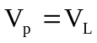, 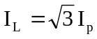

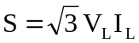

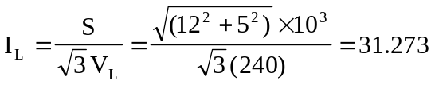

At the source,
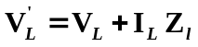+ I_{L}Z_{l}
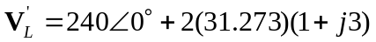 = 240+62.546+j187.638
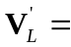302.546+j187.638 = 356∠31.81°
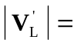356 V

Also, at the source,
S’ = 3(31.273)²(1+j3) + (12,000+j5,000) = 2,934+12,000+j(8,802+5,000)
= 14,934+j13,802 = 20,335∠42.744° thus, θ = 42.744°.

pf = cos(42.744°) = 0.7344

Checking, V_{Y} = 240/1.73205 = 138.564, S = 3(138.564)²/(Z_{Y})* = 12,000+l5,000, and Z_{Y} = 57,600/(12,000–j5,000) = 57.6/(13∠–22.62°) = 4.4308∠22.62° = 4.09+j1.70416. The total load seen by the source is 1+j3+4.09+j1.70416 = 5.09+j4.70416 = 6.9309∠42.74° per phase. This leads to θ = Tan⁻¹(4.70416/5.09) = Tan⁻¹(0.9242) = 42.744°. Clearly, the answer checks. I_{l} = 138.564/4.4308 = 31.273 A. Again the answer checks. Finally, 3(31.273)²(5.09+j4.70416) = 2,934(6.9309∠42.74°) = 20,335∠42.74°, the same as we calculated above.

